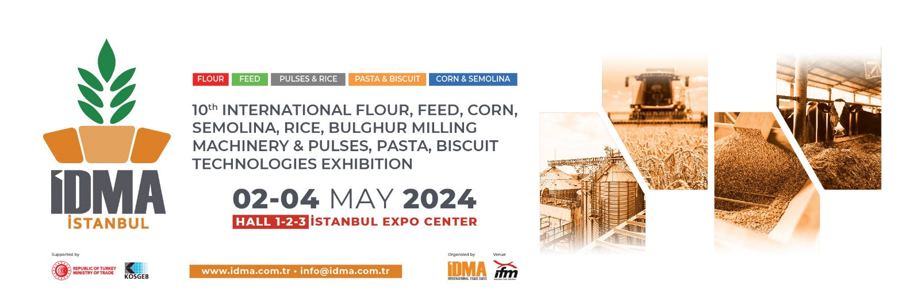
WHY YOU SHOULD VISIT IDMA ISTANBUL?
You should visit IDMA ISTANBUL expo certainly if you operate in grain, feed and pulses processing industry and aim at investments!

BECAUSE in IDMA ISTANBUL which is the only technology exhibition with broad participation in grain, feed and pulses processing technologies;

• Wide range of machinery, products and services sought for any company are available at same place,
• The latest technologies improved regarding relevant expertise area can be seen and analysed closely,
• The opportunity to interview with the biggest technology companies participating to the fair, to receive respond to relevant questions and to make cooperation with them,
• The possibility to compare companies developing similar Technologies and accordingly, the technologies improved by such companies,
• The possibility to have knowledge about many issues, such as latest technological improvements, developing markets, production-consumption data in the world, new trends, etc. By means of the activities arranged within the scope of the fair.

TECHNOLOGIES EXHIBITED
MILLING | Flour Milling Machines and Equipment  Semolina Milling Machines and Equipment  Corn Milling Machines and Equipment |  | PASTA  &  BISCUIT | Pasta Production Machines, Equipment and Additives  Biscuit Production Machines, Equipment and  Additives
FEED | Feed Milling Machines and Equipment  Feed Additives |  | CORN  &  SEMOLINA | Grain Storage Silos, Storage, Conveying and  Unloading Systems, Laboratory Equipment,  Additives, Packaging Machines and Equipment,  Spare Parts and Sub Industry
PULSES  &  RICE | Pulses Cleaning and Packaging Machines and Equipment  Rice Milling Machines and Equipment
INVITATION FORM
Please fill out the form below and send it us back to : Meriem.altindere@idma.com.tr
Company Name: |  |  |  |  | Not:
Name & Surname:
Phone:
Fax:
GSM:
E-Mail:
Address:

