LIST OF DELEGATES FOR UKARINE
# | Members Detail | Status | Business Interest | Sector division for B2B
 | Mian Nasser Hyatt Maggo  Director  M/s Al-Riaz Agencies (Pvt.) Ltd.  408-410, Chapal Plaza, Hasrat Mohani Road  Karachi  T. 0092-21-32446310  M. 0092-321-8223232  E: nasser@alriaz.com  Web: www.alriaz.com  Accompanied by:  Ms. Seema Nasser Maggo  Wife of Mr. Nasser Hyatt Maggo | President FPCCI | Petrochemicals/Chemicals and Indenting | Indenter & chemical importer
 | Mr. Nasir Khan  Proprietor  Farooq Ghee & Oil Mills, Quetta  Quetta  T. 081-2821943  F. 081-2821948  M. 0321-8038811  E. qcci920@gmail.com  W.www.qccib.com.pk | Vice President | Production of edible oil | interested to meet importer and exporter Edible Oil, plastic & paper
 | 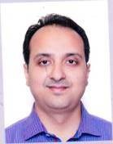  Mr. Adeel Siddiqui  Chief Executive  Premier Oil Industry,  N/29 Site kotri, Site Kotri District,  Jamshoro  T: 022-2116520-21  M: 0300-3011799  E: itzadeel84@gmail.com | Vice President | Importer of Paints & Chemicals | interested to meet paints and chemicals exporters
 | 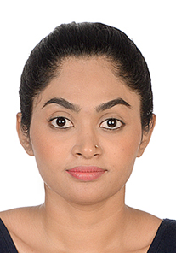  Ms. Mehreen Razzak  Manager, FPCCI  Ph: 021-35873691-4  Fax: 021-35874332  Eml: manager.jbc@fpcci.org.pk | Manager, FPCCI | FPCCI Official
 | 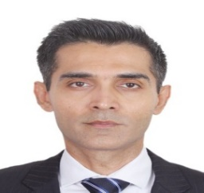  Mr. Shahzad Sabir  Partner,  M/s. Metropolis Trade International  C-47Cutchi Memon Co-Operative Housing Society, Bahadurabad, Karachi.  Ph: 021-32735168  Fax: 021-32735419  Mob: 0300-8232210  Eml: metropolis.ti@outlook.com | Chairman  Pakistan-Belarus Business Council | Import and Export of Timber & Wood-Based Products | To meet with raw timber and lumber exporters and producers for future endeavors.
 | 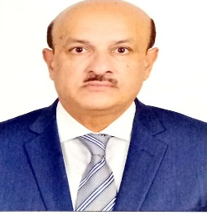  Mr. Pervez Haroon Madraswala  Managing Director  M/s. Pierlite Pakistan (Pvt) Ltd.  611, The Forum, Khayaban-e-Jami, Clifton, Karachi  Tel: 111- 509- 509  Fax: 021-35360974  Cell: 0300-8221793  Eml: pervez@pierlite.com.pk | Director Pakistan-Belarus Business Council | Importer of Electrical & Lighting | interested to meet exporters of light sources
 | 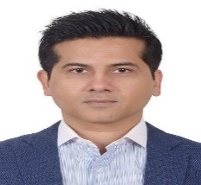  Mr. Faisal Lodhia  Managing Director,  M/s. Lodhia Gypsum Industries (Pvt) Ltd.  Suit # 105, Business & Finance Centre, I.I. Chundrigar Road, Karachi.  Ph: 021-111-332-497  Fax: 021-32423721  Mob: 0321-8293603  Eml: faisallodhia@arishdrywall.com  Web: www.arishdrywall.com | Director, Pak-Belarus Business Council 2021 | Import and export of Gypsum Plaster/ Gypsum Board | interested to meet importers of building materials
 | 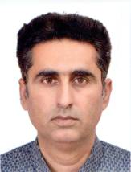  Mir Naveed Jan Baloch  Proprietor  Makran Traders  New Town Housing  Gwadar  1/3 – A, Phase 5, B street  D.H.A., Karachi  M. 0321-3778373  E.mirnaveed@gwadargg.com | President, Gwadar Chamber of Commerce & Industry | Transportation, Real Estate | joint venture purpose
 | 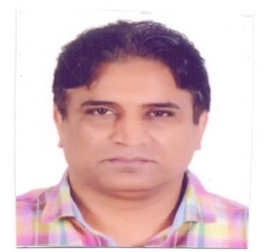  Sheikh Muhammad Iqbal Sony  Partner  M/s. Abro Group  S.I.E, Abrona Street, Fateh Garh Road, Sialkot (51310).  Tel: 052-3250020  Fax: 052-3554838  Cell: 0321-6109100  Eml: info@abrogroup.com | Member- Business Council | Export of Military & Policies Gloves & Accessories | To meet with the importers of the tactical products
 | 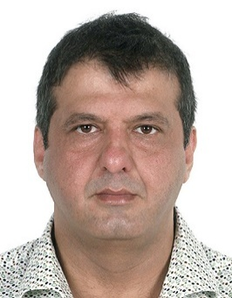  Mr. Rameez Sattar  Chief Executive Officer  M/s. Sonraj Pakistan  D-62/1, KDA Scheme No. 5, Clifton-4, Karachi  Tel: 021-35877559-60  Fax: 021-35878454  Cell: 0300-2124465  Eml: pir.ijlal@sonraj.com; info@sonraj.com | Chairman, Pak-Russia Business Council 2021 | Import of Watches | finished products of watches
 | Mr. Muhammad Faisal Khan  Director  M/s. Alpha Chemicals (Pvt.) Ltd.  430-G1, Johar Town Lahore  Tel: 042-35313316-17  Fax: 042-35291120  Mob: 0321-8462010  Res: 042-35235015  Eml: fslkhan@gmail.com | Member- Business Council | Manufacturing of Active Pharmaceutical Ingredients (APIs) | Interested to meet Importer of all products associated with pharmaceutical industry (injectable, capsules, tablets etc)
 | Mr. Ehtasham Ul Haque  Director  M/s. Alpha Chemicals (Pvt.) Ltd.  430-G1, Johar Town Lahore  Tel: 042-35313316-17  Fax: 042-35291120  Mob: 0300-8441091  Res: 042-35453032  Eml: ehtisham_ptc@email.com | Member- Business Council | Manufacturing of Active Pharmaceutical Ingredients (APIs) | Interested to meet Importer of all products associated with pharmaceutical industry (injectable, capsules, tablets etc)
 | Mr. Saqib Majeed  Chief Executive,  M/s Majeed Fabrics (Pvt.) Ltd.  Samana Bridge, Sargodha Road,  Dhanola Road,  Faisalabad.  T: 041-8811411-14  M: 0300-8662868  E: saqib@majeedfabrics.com  W: www.majeedfabrics.com | Member- Business Council | Exporter of Textile | woven fabric, cotton importers and to meet dying and printing of mills, finished fabric (bed sheet) importers  Company’s list to be shared
 | 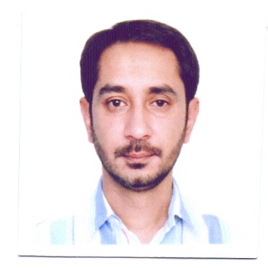  Mr. Aamir Saleem Butt  Chief Executive  M/s. Ameer Pharma Pvt Ltd. 23 KM, Sheikhpura Road Lahore.  Ph: 042-37168691  Mob: 0300-9482351  Eml: ameerpharma22@gmail.com | Member- Business Council | Exporter of Pharmaceutical | injectable importers  hormones general and antibiotics
 | Mr.Mohammad Idrees  Chief Executive Officer  M/s. Navamed Pharmaceutical Pvt. Ltd  28-Km, Ferozepur Road, Lahore  Ph: 042-35403361-4  Res: 0313-2891111  Mob: 0300-8449960  Eml: m.idrees@novamed.com.pk | Member- Business Council | Exporter of Pharmaceuticals | injectable, syrup, capsules importers  nutraceutical Joint ventures
 | Mr. Shafiq Ahmad Abbasi  Sole Proprietor  M/s. Shafiq Enterprises  97-Aurangzeb Block, New Garden Town, Lahore  Ph: 042-35928138  Res: 042-5415566  Mob: 0300-8485055  Eml: selp86@hotmail.com | Member- Business Council | Exporter of Pharmaceuticals | Interested to meet Importer of all products associated with pharmaceutical industry (injectable, capsules, tablets etc)
 | 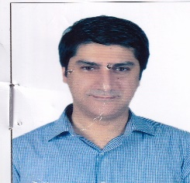  Mr. Adnan Ghani  Chief Executive  M/s. Ameer & Adnan Pharmaceuticals (Pvt) Ltd.  Plot No. 47, Sundar Industrial Estate, Lahore, Pakistan  Ph: 042-35299746-7  Mob:0300 9042811  Email: ameeradnanpharma@gmail.com | Member- Business Council | Exporter of Pharmaceutical | Interested to meet Importer of all products associated with pharmaceutical industry (injectable, capsules, tablets etc)
 | Mr. Kamran Butt  Chief Executive  M/s. Amaan Pharma  30-K.M. Sheikhpura Road, Lahore.  Mob: 0332-4843848  F | Member- Business Council | Exporter of Pharmaceuticals | human injectable items importers
 | Mr. Fahad Shoaib  Director  M/s. Amaan Pharma  30-K.M. Sheikhpura Road, Lahore.  Mob: 0333-8722266 | Member- Business Council | Exporter of Pharmaceuticals | human injectable items importers
 | Mr. Hamid Raza  Chief Executive  M/s. Neutro Pharma (Pvt). Ltd.  9.5 Km, Sheikhpura Road, Lahore  Ph: 042-37339086  Mob: 0321-7915786 / 03219989786  Eml: hamidraza@neutropharma.com | Member- Business Council | Exporter of Pharmaceuticals | human injectable items importers
 | Mr. Samin Jan Zafar  Proprietor  M/s. Agha Mining & Construction Company  M.A Jinnah Road, Near Quetta Medical Store, Quetta  Mob: 0315 0000027  Mob: 0333-2276877 | Member- Business Council | Supplier of Coal Miner | joint venture in construction projects
 | Mr. Khaliq Hussain  Director  M/s. Green Services (Pvt) Ltd.  Mob: +92 321 8237903 | Member- Business Council | Construction | Joint venture purpose
 | Mir Washane Bugti  Director  Gwadar Global Gateway (Pvt) Ltd.  Karachi Office: Plot 1C, Stadium Lane II, Phase V, DHA, Karachi  Gwadar Office: HJ-15, Phase-I, New Town Housing Scheme, Opp Coast Guard, Gwadar, Baluchistan  Tel: 021-35248687-88  Mob: +92 304 7776888  ‎Mob: +92 323 8221996 | Member- Business Council | Financial Investments  (Real Estate) | Joint venture purpose
 | Sheikh Waseem Ahmed  Managing Director  M/s. Daily Chemicals  Mob: 03216372007  Email: wasim123@hotmail.com | Member- Business Council | Importer of Chemicals | food ingredients surfinfectant
 | Mr. Haris Jawaid  Proprietor  M/s. Brothers Trading Corporation  47/E, 21st Commercial Street, Defence Phase II, Extension DHA, Karachi.  Tel: 021-32311652-56  Mob: 0300-2613416  Eml: haris.jawaid@gmail.com | Member- Business Council | Indenting & Trading | Indenter
 | Mr. Abdul Jabbar  Chief Executive  Qaim Automotive mfg. (Pvt) Ltd.  108/II,5th street, off.kh-e-Muhafiz  Phase VI, D.H.A , Karachi  Mob: 0300-8236782 Email: engrmajabbar@qaimfilters.com.pk Email: engrmajabbar@gmail.com  Mrs. Mumtaz | Member- Business Council | Culture & Education | Automotive industrial and power generation filters
 | Ms. Sunayna Ismail Sajwani  Director  M/s. Sunayna Enterprises Ltd.  A-10, Jason VIP Apartments, Block-7, Clifton, Karachi.  Mob: 0333-3383646  Email: sunaynaismail1@gmail.com | Member- Business Council | Exporter of Textile | home textile, institutional interested to meet importer and exporter both
 | Muhammad Tahir Iqbal  Managing Director  M/s. Novamed Health Care Pvt Ltd.  28-Km, Ferozepur Road, Lahore  Ph: 042-35271160-62  Res: 0321-2434358  Eml: info@novamedpharma.com.pk | Member- Business Council | Exporter of Pharmaceutical | interested to meet medicines, injectable, capsules, tablets eye drops importers
 | 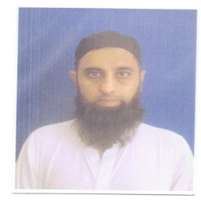  Mr. Raheel Kaiser  Executive Director  M/s. Medisure Laboratories Pakistan Pvt Ltd.  A-115, S.I.T.E II, Super Highway Karachi.  Ph. 021-111-786-007  Res:021-35800887-35895288  Mob: 0300-8267884  Eml: r.kaiser.medisure@gmail.com  Web: www.medisure.com.pk | Member- Business Council | Exporter of Pharmaceuticals | interested to meet medicines, injectable, capsules, eye drops importers
 | Mr. Sunil Kumar  Proprietor  M/s. Agarwaal Enterprises  711,712, Chapal Plaza 7th Floor, Hasrat Mohani Road, Karachi  Mob: 0333-7961000  Eml: vickyagarwal462003@yahoo.com | Member- Business Council | Importer of Palm Oil/ Palm Olein | will meet palm oil exporter
 | Mr. Muhammad Ibrahim  Director  M/s. Ismail Fabrics  119 JB Samana Bridge, Sargodha Road, Off Shalimar, Road Faisalabad  Ph: 041-8869149  Mob: 0321-8869149  Eml: ibrahim@ismailfabrics.com | Member- Business Council | Manufacturers & Exporters of Home Textile | home textile, institutional interested to meet importer and exporter both
 | Mr. Akbar Khan  Senior Vice President  Swat Chamber of Commerc & Industry  G.T Road Mingora  Ph: 0946-711553  Fax: 0946-711554  Off: 0946-811911  Cel: 0346-8387777  Email: akbarkhana838@gmail.com | Member- Business Council | Exporter of Gems & Stone | will want to meet gems/stone and handicraft importers
 | Malik Muhammad Aijaz Nazam  Managing Director  M/s. Nazam Industries  Edi Oil Industroes Pvt Ltd.  Multan By Pass Road, Bahawalpur.  Ph: 062-2881740./2881109/ 28888845  Fax: 062-2720828  Mob: 0300-8680475 | Member- Business Council | Production of Edile Oil / Seeds/ Cotton Ginning | importers for textile (raw cotton and spinning)
 | Mr. Musawar Saeed  M/s. Construction Art  208-A, Main Commercial Area, Sector C, Bahria Town, Lahore  Ph: 042-37861331  Mob: 0333-7476677  Eml: info@constructionart.co  Web: www.constructionart.com | Member- Business Council | Construction | would like to meet importer of tiles
 | Ch. Gulzar Ahmed  Managing Director  M/s. Royal Bashir Garden  Canal Sadiq Road, Rahim Yar Khan.  Mob: 0300-9653818  Eml: gulzarahmed.121212@gmail.com | Member- Business Council | Real State | joint venture purpose
 | Mr. Muhammad Hussain  Chief Executive  M/s. JB Seed Corporation  Shahi Road, Jetha Bhutta, Tehsil Khanpir, Rahimyarkhan  Tel: 042-35310203  Fax: 042-35315744  Mob: 0300-6700488  Mob: 0333-9110203  Eml: secretariat@sap.com.pk | Member- Business Council | Importer of Seed/ Agro Chemical | seed exporter and importer
 | Mr. Farhan Rabbani  Director Marketing  M/s. Al Mahmood Groups  C-1 3rd Floor, Jumani Arcade, Main University Road, Karachi  Ph: 021-4931980 & 82  Fax: 021-4948493  Mob: 0300-2270885  Eml: almahmoodest@gmail.com | Member- Business Council | Exporter of Fruits & Vegetable | importers of fruits (mandarins)and vegetables (potatoes) big supermarkets retailers (import department)
 | Mr. Saeed Ahmed Sheikh  Managing Marketing  M/s. K.B. Enterprises  M/s. Fairdeal Mils (Pvt) Ltd.  19-Km, Sheikhupura Road Faisalabad  Ph: 041-2423711-14  Fax: 041-2423710  Mob: 0300-6639816  Eml: saeed@fairdeal.pk | Member- Business Council | Exporter of Textile | home textile, institutional hotel & hospital, towel and spinning interested to meet importer and exporter both
 | Mr. Nazir Nasir  Chief Executive Officer  M/s. K.B. Enterprises  19-Km, Sheikhupura Road Faisalabad  Ph: 041-2423711-14  Fax: 041-2423710  Mob: 0300-8665719  Eml: info@kbenterprises.com.pk | Member- Business Council | Exporter of Textile | home textile, institutional hotel & hospital, towel and spinning interested to meet importer and exporter both
 | Muhammad Waheed Chaudhry  Chief Executive  M/s. Hunza Sugar Mills Pvt. Ltd.  1-A, New Muslim Town , Lahore  Ph: 042-35882941-6  Uan: 042-111-161-161  Fax: 042-35862245  Mob: 0300-8427701  Eml: waheed.ch1@hotmail.com | Member- Business Council | Exporter of Sugar Mills /Traders/ Power | interested to meet importer of sugar
 | Hafiz Ghulam Mustafa  Director  M/s. Hafiz & Co.  New Grant Market  Rahimyar khan, Khanpur.  Mob: 0301-6672323/ 0345-8880202  Email: | Member- Business Council | Import/Export Fertilizer | interested to meet importer as well as exporter of fertilizer
 | Mr. Habibullah Zahid  Chief Executive Officer  M/s. Habibi Chain of Restaurant  Tel: 051-4448222  Mob: 0300-8585851  Eml: habibi_resturant@hotmail.com | Member- Business Council | Hotel & Restaurant | Joint venture
 | Mr. Subhan Shahid  Director Export  S.B Weaving  Sargodha Road Faisalabad | Member- Business Council | Exporter of Textile/ Spinning/ Weaving | cotton weaving home textiles + intuitional importers interested to meet
 | Mr. Mudassir Ahmed  Managing Director  M/s. Haiqa Traders  Office, G-276, Zakaria ChowkTeh, Talang, District Chakwal, Punjab Pakistan.  Tel: 054-3695200  Mob: 0300-5474939  Eml: haiqatraders.pk@gmail.com | Member- Business Council | General Trading /Import / Export | Himalayan pink salt importer and exporter
 | Mr. Rizwan Sadiq  Director  M/s. Citrus Asia Enterprises  Chak. No. 104 NB Sillanwali Road Sardogha, Punjab.  Tel: 048-3768500  Mob: 0321-4070450  Email: citrusasia@gmail.com | Member- Business Council | Exporter of Fruit & Vegetable | potatoes, mangoes and Mandarin importers
 | Mr. Mahboob Hussain Sagar  Managing Director  M/s. Noorani Darul Jarahat  Dr. Mahboob Jarah Street, Near Highway Office, Talagang.  Mob: 0333-5925253 | Member- Business Council | Health Services | Himalayan pink salt
 | 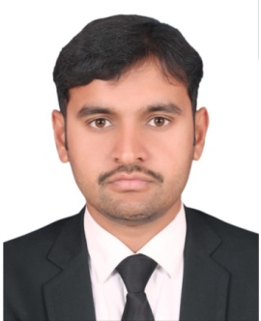  Mr. Yaser Mahmood  Managing Partner  M/s. Intaj International (Pvt) Ltd.  Wazirabad road, Near Police Station Sambrial Distt. Sialkot  Ph: 92-52-6524052  E: intajinternationalskt@gmail.com  Web: www.intajinternational.com | Member- Business Council | Millers & Exporters of Rice | basmati rice importers
 | Mr. Saif ullah  Chief Executive Officer  M/s. New Mushtarka Mohmand Goods Transport & Fruits, Vegetables  Haji Dilawar Khan Market Matta Road Shabqadar Bazar, Charsadda | Member- Business Council | Exporter of Fruits & Vegetable | potatoes, mangoes and Mandarin importers
 | Ali Raza Memon  Chief Executive  Qaim Automotive mfg. (Pvt) Ltd.  108/II,5th street, off.kh-e-Muhafiz  Phase VI, D.H.A , Karachi  Mob: 0300-8236782 Email: engrmajabbar@qaimfilters.com.pk Email: engrmajabbar@gmail.com | Member- Business Council | Automotive | Automotive industrial and power generation filters
 | Mr. Zabihullah  Chief Executive Officer  M/s. ZKD Construction & Marketing  Office No. 1, 3rd Floor ZKD Tower, Near GPO Chowk, Circular Road, Quetta.  Mob: 0300-9388722  Eml: zkd.722@gmail.com | Member- Business Council | Construction/Builders | joint venture in construction sector
 | Mr. Hamd Zahid  Chief Executive Officer  M/s. K.B. Enterprises  19-Km, Sheikhupura Road Faisalabad  Ph: 041-2423711-14  Fax: 041-2423710  Mob: 0304-1004900  Eml: Hamdzahid@kbenterprises.com.pk | Member- Business Council | Exporter of Textile | home textile and fabric (interested to meet importer and exporter)
 | Mr. Naheed Abbas Malik  Managing Director  M/s. Red Gazal Bus Rental LLC  Ph: +971505486954  Cell: 0333-5134133 | Member- Business Council | Transport/Logistic | Himalayan pink salt
 | Abdul Ghani  Chairman  M/s. Ghani Osman Securities (Pvt) Ltd.  Pardasi House, Survey No. 2/1, RY-16, Old Queen Road, Karachi  Ph: 021-32470245  Mob: 0300-8221082  Eml: hajighani@aasml.com  Web: gosecurities.com.pk  Ms. Aasia  Wife of Abdul Ghani | Member- Business Council | Exporter of Sugar Mills /Securities Agency | interested to meet sugar importers plus financial markets representatives
 | Mr. Farid Khan  Proprietor  M/s. FB Automobiles  Mob: 0315-6457367  Eml: fareedBaloch.com | Member- Business Council | Importer of Automobile | Interested to meet manufacturers of all parts of automobiles.
 | Ms. Benish Imtiaz Khan  Proprietor  M/s. BSK Traders  Office No. 120, 1st Floor, Techno City, Tower, Hasrat Mohani Road, Karachi.  Mob: 0313-4496641  W.ap: 00230-59352666  Eml: drbenish87@gmail.com | Member | Traders / Consultant | interested to meet importer and exporter of general trading
 | Abdul Karim  Proprietor  M/s. Nizamia Traders.  Mob: 0321-9708247  Email: nizamiarice@gmail.com |  | Exporter of Masala Jatt, Beans, Rice, Chickpeas. | Interested to meet importers of beans rice, chickpeas
 | Mr. Rasheed Ahmad  President Kohat Chamber of Commerce Industry  Proprietor  M/s. Rasheed Traders  Shah Sultan Plaza Bannu Bazar Kohat.  Mob: 0321-8150011  Email: hrasheedparacha@gmail.com |  | Exporter of Masala Jatt, Exporter of Beans, Rice, Chickpeas. | Interested to meet importers of beans rice, chickpeas
59 | Mr. Naeem Aman  Proprietor  M/s. Naeem Aman Traders  Shop#15, Ground Floor Jinnah Plaza University Road Karachi.  Mob: 0333-9616609 |  | Herbal and foods. | red beans, cereals and herbals
60 | Zaheer Ahmed  Managing Director  Uzair Engineering Works  128, Defence Phase 1, Hyderabad.  Mob: 0300-8377666  Tel: 022-2108555  Email: uzairenggworks@gmail.com | Member of Business Council | Construction | Joint venture
61 | Muhammad Moosa  Managing Director  La Moosh (Café & Restaurant)  Banglow # 8/A, besides Cotton & Cotton, Boat Basin, Clifton Karachi.  Mob: 0345-5177786  Email: muhammadmoosa@gmail.com | Member of Business Council | Restaurant and Cinema. | Joint venture
62 | Muhammad Sadiq Shoro  CEO  Sadiq Farms  26/1 Eid Gah Sehwani Mohallah Kotri, Distt: Jamshoro.  Mob: 0300-0200264/ 0300-9377642  Email: msadiqshoro@hotmail.com | Member of Business Council | cattle farming | cattle farming and irrigation related facilities
63 | Muhammad Aamir  CEO & President.  Gexton Group Of Companies  A21, 3rd Floor, Opp: Mehmood Garden, Auto Bahn Road, Hyderabad.  Mob: 0301-8222720  Tel: 022-3812300 / 022-3821566-77  Email: aamir@gexton.com / info@gexton.com | Member of Business Council | Software and IT. | interested to meet exporters of hotel industry, retailers and wholesales, products  (joint ventures in IT sector as well)
64 | Mr. Yasir Liaqat  Director  M/s. FYNK Pharmaceuticals  299-Hadayat Ullah Block, Mustafa Town, Wahdat Road, Lahore.  Ph: 042-35427780-81 042-35416330  Fax: 042-35427782  Mob: 0321-438138  Mob PA: 0300-9434779 | Member-Business Council | Pharmaceuticals | Interested to meet Importer of all products associated with pharmaceutical industry (injectable, capsules, tablets etc.
65 | Mr. Irfan ullah  Chied Executive Officer  M/s. Frontier Customer Services and Agro Foods  Opposite Ufone Franchise Matta Road Shabqadar bazar, Charsadda | Member- Business Council | Agro Foods | interested to meet importer and exporter of agro foods importer and exporter
66 | Mr. Ihsan Ul Haq  Chief Executive  M/s. Ihsan Traders  Room No. 14, 4th Floor Dildar Plaza, Nardan Road, Swabi City.  Ph: 0938-470470  Mob: 0334-4704700 | Member- Business Council | Textile/ Home Textile | home textile and fabric (interested to meet importer and exporter)

